Waterfall methodology
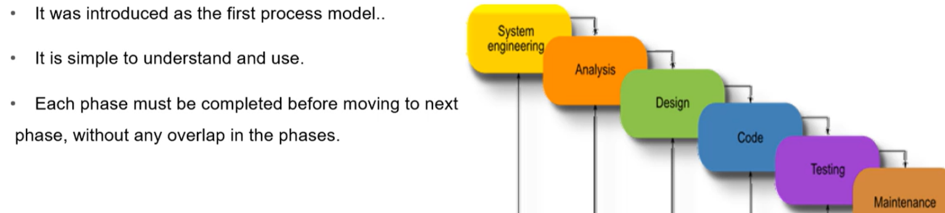
6.1. The Waterfall Model
A linear, sequential model where each phase must be fully completed before the next begins.
It is rigid and does not easily accommodate changes.

● Phases: Requirement Gathering -> Analysis -> Design -> Implementation -> Testing ->
Deployment -> Maintenance.
● Best For: Projects with stable, well-understood requirements where changes are unlikely.
For example, automating a long-standing manual process like LIC's premium collection. 